WEB REPORT 7
Group: SE-2429
Name: Daryn Musseyev
Part 1 – Getting Started with jQuery
Task 0 – Setup
- jQuery was successfully included from the official CDN (https://code.jquery.com/jquery-3.7.1.min.js).
- A $(document).ready() function was created to ensure that all code runs only after the DOM is fully loaded.
- The message “jQuery is ready!” was printed to the console to confirm that jQuery was correctly initialized and working.
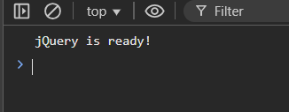
Task 1 – Selectors & CSS
This part demonstrates the use of jQuery selectors, CSS manipulation, and DOM updates through different interactions.
1. Selecting elements
- Elements were selected by class, ID, and tag:
  - 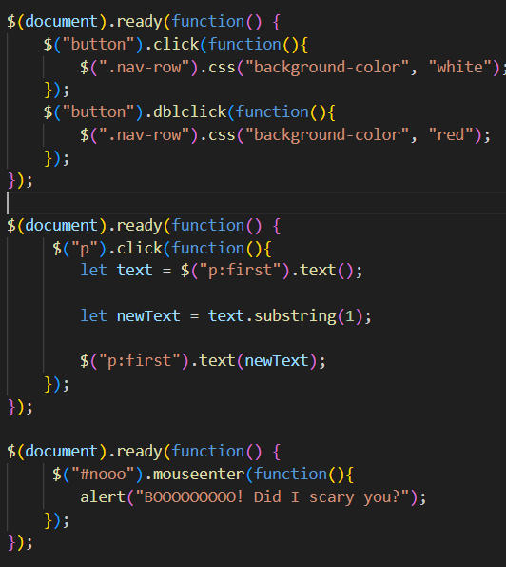
2. Changing content and style
- A button click changes the navigation bar’s color to white using .css("background-color", "white").
- A double-click on the same button changes the color to red.
- This demonstrates how .css() dynamically modifies element styles via jQuery.
3. Text modification
- When the user clicks on the paragraph, the script retrieves its text using .text().
- The first character is removed with the substring(1) method.
- The updated string is then re-assigned to the same paragraph with .text(newText).
- Each click removes one character from the beginning of the paragraph text.
4. Event interaction
- When the user hovers the mouse over the <h1> element with ID #nooo, an alert message appears (“BOOOOOOOOO! Did I scary you?”).
- 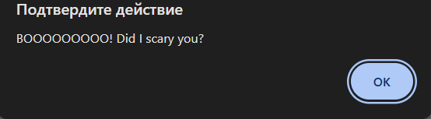
- This demonstrates the .mouseenter() event in jQuery.

Part 2 – jQuery Effects
Task 2 – Visibility Methods
Goal: Demonstrate how to show, hide, and toggle elements dynamically.
Implementation:
- A paragraph (<p>Halloween will be on Friday</p>) was created along with three buttons: Hide, Show, and Toggle.
- When clicking:
  - The Hide button → hides the paragraph using .hide().
  - The Show button → reveals the paragraph again with .show().
  - The Toggle button → alternates between showing and hiding the paragraph with .toggle().
- These interactions demonstrate how jQuery controls an element’s visibility in real time.
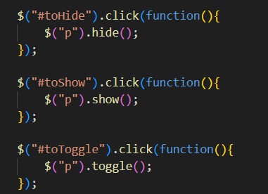
Task 3 – Fade Methods
Goal: Apply fading effects to an image.
Implementation:
- An image of a pumpkin (<img src="Halloween_Pumpkin_PNG_Clipart.png" class="pumkin">) was added along with three buttons: Fade in, Fade out, and Fade toggle.
- When clicking:
  - Fade in → makes the image appear gradually using .fadeIn().
  - Fade out → hides the image smoothly with .fadeOut().
  - Fade toggle → alternates between fading in and fading out with .fadeToggle().
- These methods create a smooth visual transition effect, useful for dynamic image galleries or interactive web design.
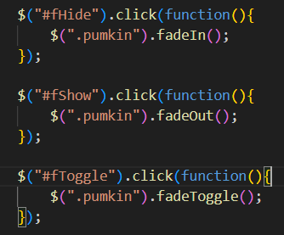
Task 4 – Slide Methods
Goal: Create a collapsible panel that can slide open or closed.
Implementation:
- A small text panel was built using two <div> elements:
  - #flip → clickable header (“Click to slide up panel”).
  - #panel → hidden content (“Boo! Halloween tomorrow!”).
- When clicking on #flip, the panel expands or collapses using .slideToggle("slow"), creating a smooth sliding animation.
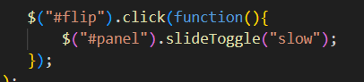

Part 3 – DOM Manipulation with jQuery
Task 5 – Add & Remove Elements
Goal: Learn to dynamically add and remove elements from the DOM using jQuery methods.
Implementation:
- An ordered list (<ol>) was created with three buttons: Append, Prepend, and Remove.
- When clicking:
  - Append → adds a new list item (<li>Spooky, scary skeletons</li>) to the end of the list using .append().
  - Prepend → adds the same item to the beginning of the list using .prepend().
  - Remove → deletes the last item in the list with .remove().
- This demonstrates how elements can be dynamically inserted and deleted without reloading the page.
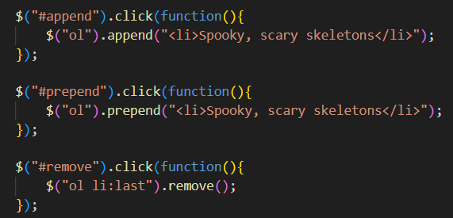
Task 6 – Modifying Attributes
Goal: Learn how to modify HTML attributes and text content dynamically.
Implementation:
- An image and heading (<h3>Don't dare click the button!</h3>) were used along with a button labeled “Change the picture”.
- When the button is clicked:
  - The text of the heading changes to “why did you do it?” using .text().
  - The image’s src attribute is updated from "skeleton.jpg" to "Boo.jpg" using .attr("src", "Boo.jpg").
- This shows how jQuery can modify both element content and HTML attributes interactively.
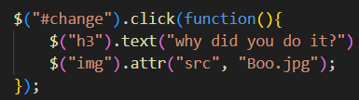
Task 7 – Form Interaction
Goal: Display live user input from a form using .val() and .text().
Implementation:
- A form with two input fields — Name and Email — was created.
- As the user types:
  - The Name field updates the text inside <span id="displayName"> in real time.
  - The Email field updates <span id="displayEmail"> the same way.
- This was done using the .on("input") event combined with .val() to get input values and .text() to display them.
- The result is a live preview that reflects the user’s typing instantly.
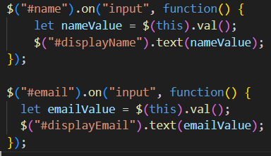

Part 4 – Animations (jQuery)
Objective
The goal of this part was to practice using jQuery’s .animate() method to create smooth, dynamic animations. The tasks focused on manipulating CSS properties such as position, size, and opacity, both individually and in sequence.

Task 8 – Basic Animation
Description:
A square <div> element was animated to move to the right and increase in size using the .animate() method.
Code Explanation:
When the user clicks the “Move” button, the animation changes three CSS properties:
- left: moves the box horizontally to 250px.
- height and width: increase the size of the box.
Result:
The square smoothly grows and moves to the right.
Key Code Snippet:
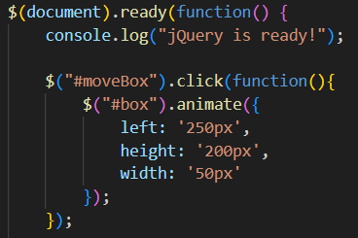
Task 9 – Sequential Animations
Description:
This task demonstrates multiple animations executed in sequence — moving, resizing, and returning to the starting position.
Code Explanation:
The .animate() method was called several times one after another. Each call waits for the previous animation to finish, creating a smooth sequence:
- Move right (left: '250px')
- Move down (top: '250px')
- Shrink (width and height set to 50px)
- Return to the original position and size.
Result:
The box moves in multiple directions and changes size step by step.
Key Code Snippet:
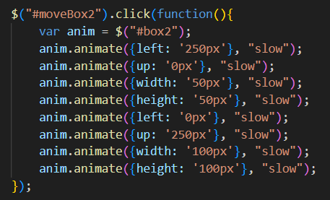
Task 10 – Combined Animation
Description:
The final task combines multiple effects into one animation call.
Code Explanation:
Using .animate(), several CSS properties were changed simultaneously:
- left: moves the box to the right
- height and width: increase size
- opacity: fades the box slightly
Result:
The animation simultaneously changes position, size, and opacity, creating a visually appealing effect.
Key Code Snippet:
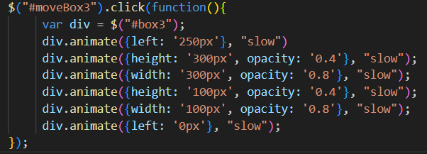

Part 5 – Mini Project: Accordion Menu
Objective
The goal of this mini project was to design and implement an interactive accordion menu using jQuery. The project demonstrates dynamic content control through slide animations, allowing only one section to expand at a time while the others collapse automatically.
Project Description
An accordion menu consists of multiple sections, each with a title (header) and a hidden content area (panel).
When the user clicks on a section title, its corresponding panel slides down to reveal content, while all other panels slide up and close.
This provides a clean and organized way to display large amounts of information in a small space.
Implementation Details
HTML Structure
Each section is composed of two main elements:
- A clickable header <div> with the class .flip
- A corresponding content panel <div> with the class .panel
There are five sections, each containing unique Halloween-themed text.
Example:
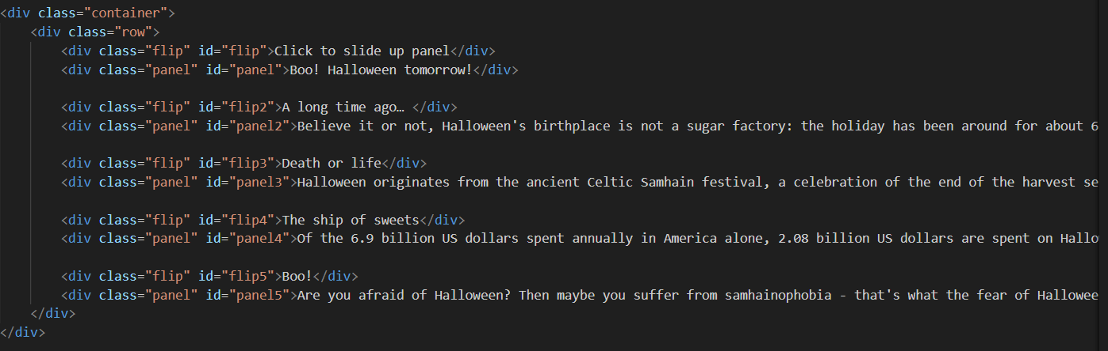jQuery Logic
The jQuery code uses the .slideToggle() and .slideUp() methods to control visibility with smooth animations.
Key points:
- When a user clicks on a header (e.g., #flip), its corresponding panel slides down or up using .slideToggle("slow").
- All other panels are hidden immediately using .slideUp("slow") to ensure only one panel is visible at a time.
- Each section is controlled independently, providing clear navigation through the accordion.
Example Code:
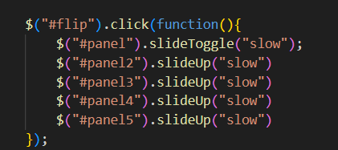This logic is repeated for each header-panel pair, maintaining consistent behavior throughout the menu.

